Shipment Price Prediction

*Wireframe Document*

**Project By:**

Deepraj Vadhwane

Shanu Singh

Roushan Singh

Kaushlendra kumar

Kiran Raghuwanshi

Farheen Syed

Hari Prasad Kale

# Wireframes

## Design Wireframes

Wireframe is a basic visual interface guide that suggests the structure of an interface and the relationships between its pages. They serve as a blueprint that defines each Web page’s structure, content and functionality. Wireframes are created before any design work is started so that the focus is on the layout without the distraction of colour and visual elements.

## Gathering Requirements

Wireframes will often help to flush out new requirements and questions that may not have been considered by the project team. Wireframes often end up evolving into the requirements for a system. Wireframes can be created using a variety of software applications online or offline.

## Functional Wireframes

This is another type of wireframe that is used in building web applications. It shows not only how each page is structured but information about each widget, button, field, each piece of content, and what page is rendered by an action. It provides a map of the entire page of the Web site, its function and its features. Even the message that may be rendered by behaviour can be included in this type of wireframe. I wanted to provide some background for this Web application process so that it would be clear what the wireframes represent. The purpose of the Web application is to provide a tool for users to create and maintain FAQs. Users can be either general users (who create and maintain their FAQs) or system administrator who not only has the same authority to develop and maintain FAQs but also maintains users (i.e., assigns new users or deletes existing users). The following screen captures are some of the general user wireframes.

# Homepage

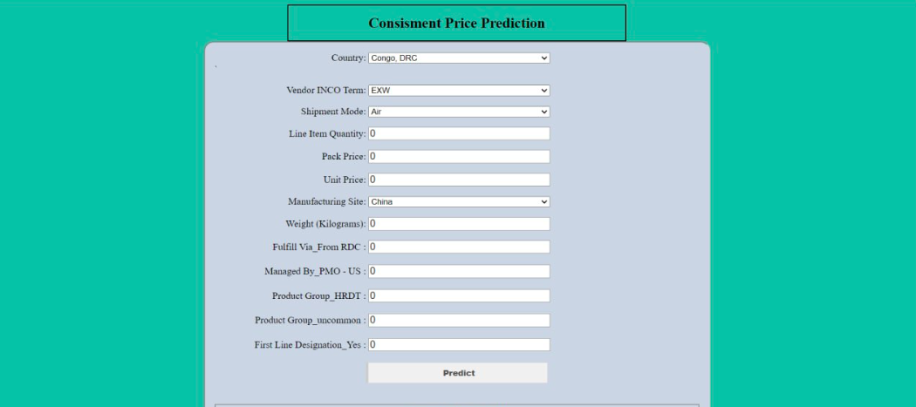

Frontpage has two sections – The top section has a header with a logo and project name which acts as a hyperlink to the home URL, and the bottom section has formed to get input from the user. At the end we have to submit button to execute the prediction, footer holds publish yearand author information.

# Input Fields

## Country

Users would have to give information about the destination country by c

## Vender INCO Term

The vendor INCO term (also known as International Commercial Terms) for Direct Drop Deliveries. User have

## Shipment Mode

The method by which commodities are shipped to the destination.

## Line Item Quantity

Total quantity (packs) of the commodity per line item

## Pack Price

Cost per pack (i.e. month's supply of ARVs, pack of 60 test kits)

## Unit Price

Cost per pill (for drugs) or per test (for test kits)

## Manufacturing Site

Identifies manufacturing site for the line item for direct drop and from RDC deliveries(country)

## Weight(Kilograms)

Weight for all lines on an ASN/DN

## Fullfill Via_From RDC

Method through which the shipment was fulfilled: via Direct Drop from vendor or from stock available in the RDCs

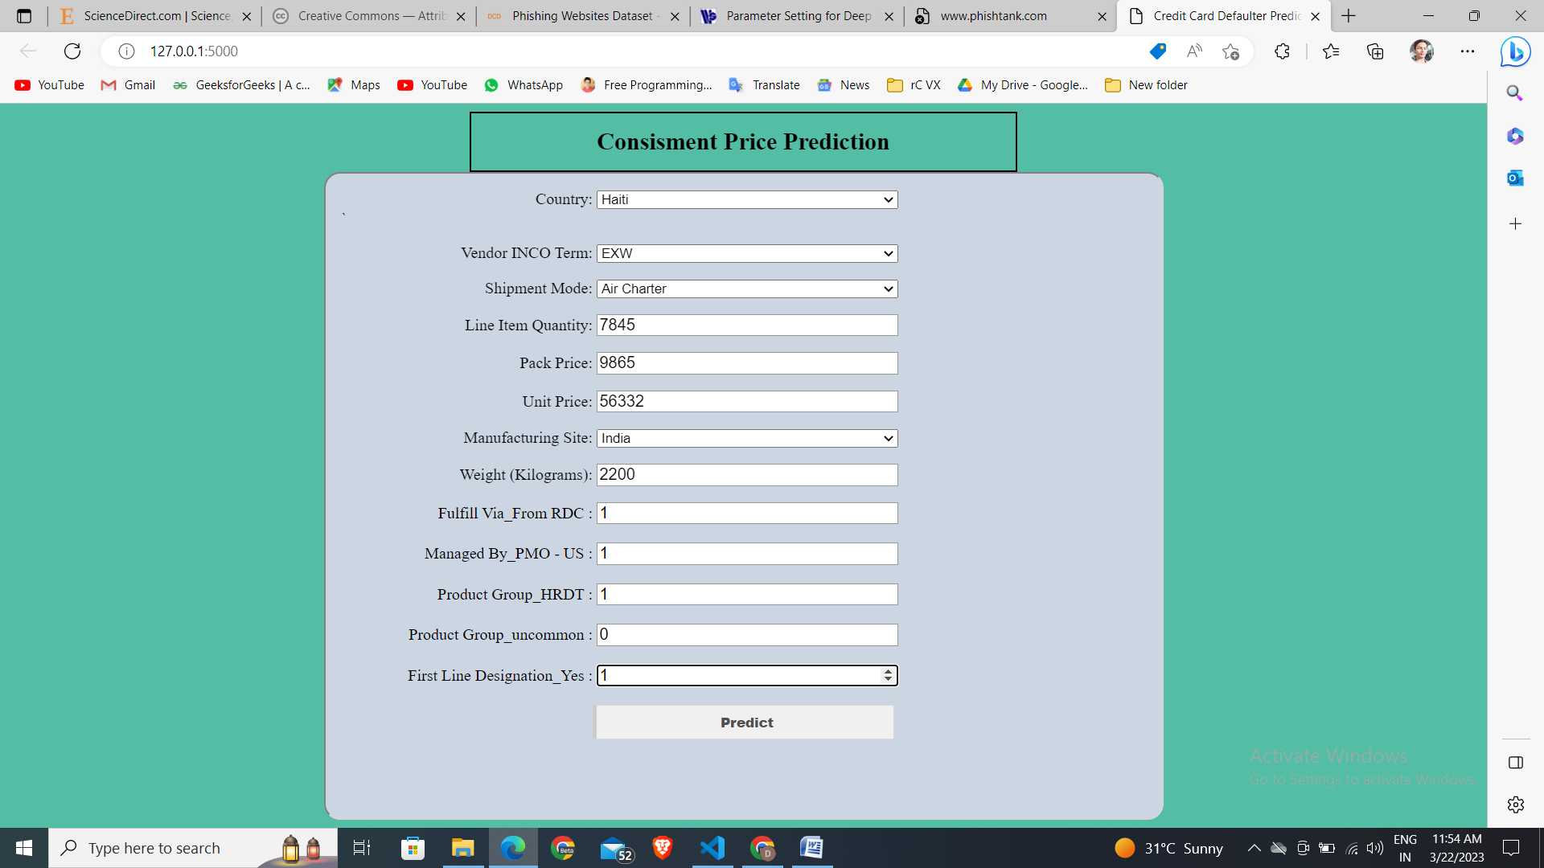

## Managed By_PMO US

SCMS managing office: either the Program Management Office (PMO) in the U.S. or the relevant SCMS field office

## Product Group

Product group for the item, i.e. ARV, HRDT

## First Line Designation

Designates if the line in question shows the aggregated freight costs and weight associated with all items on the ASN/DN (need to check)

# Predict Page

We will receive input from the user on the homepage and execute the prediction process by clicking predict button. The output result will be displayed in between two section aligned centre for convenience.

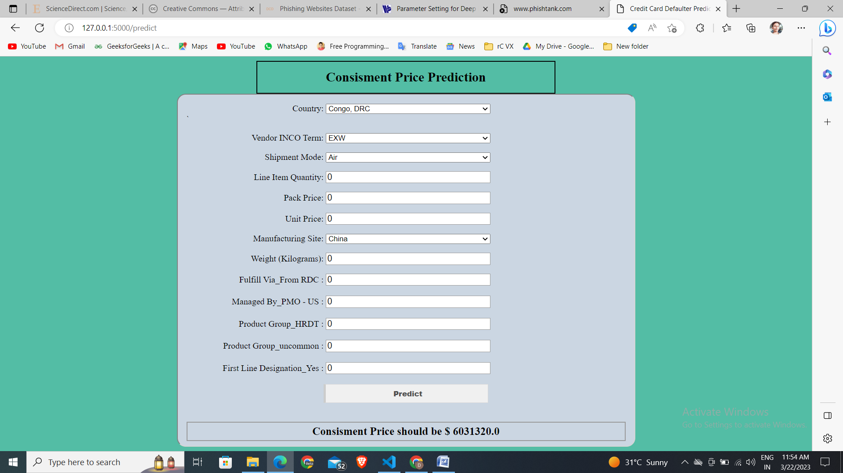

# Predict Again

User can click on the project title in the header to load homepage again and make next prediction providing all the required information of the customer